

**EE463 - STATIC POWER CONVERSION**

**Hardware Project: AC to DC Motor Drive**

**Members:**

**Hakan Saraç**

**Yusuf Basri Yılmaz**

**Sevim Ceren Yalçın**

**Table of Content**

1. Design decisions…………………………………………………………………2
2. Modeling of the topology………………………………………………………..3
3. Simulation results………………………………………………………………..4
4. Component selection……………………………………………………………7
5. Thermal Considerations..…………………………………………………….…8
6. Test Results………………………………………………………………......….9
7. Conclusion………………………………………………………………………18
8. **Design decisions**

**Topology Selection**

We have discussed the advantages and disadvantages of each three topology to make a controlled rectifier that will be used to drive a DC Motor.

**Table 1. Topology Comparison**

|  |  |  |
| --- | --- | --- |
| Topology | Advantages | Disadvantages |
| 3-Phase Thyristor Rectifier | - Easier 4 Quadrant Operation Implementation  - Low Output Ripple  - Less Passive Elements | - Thyristor Control |
| 1-Phase Thyristor Rectifier | - Easier 4 Quadrant Operation Implementation  - Less Passive Elements | - High Output Ripple  - Thyristor Control |
| Diode Rectifier + Buck Converter | - Easier Control of Semiconductors  - Easier Implementation  - Low Output Ripple | - Hard Implementation of 4 Quadrant Operation  - More Passive Elements |

At first sight, 3-Phase Thyristor Rectifier is the best option because it requires less passive elements and 4-quadrant operation is easier to implement. However, the control of the thyristor rectifiers is hard to implement, because sampling of the phases is necessary for the gate driving. Therefore, we decided not the use thyristors to rectify the AC voltages.

The implementation of the diode rectifier with a buck converter is easier because no synchronization is needed. Even though this topology requires more passive elements, the control signals for the semiconductors is much easier compared to the thyristor rectifiers. Furthermore, the number of passive elements can be reduced if THD and efficiency of the drive is not an important issue.

Considering all these, we have decided to move on with the diode rectifier with a buck converter topology. The schematic of the circuit is given below.

1. **Modeling of the topology**

After deciding on the converter topology. The model is constructed on Simulink and component selection is made accordingly. The DC Motor to be driven has 220V voltage rating and 2800W power output. The other specifications of the DC motor are as follows:

- Armature Winding: 28 Ω, 13.3 mH

- Series Winding: 65 mΩ, 260 uH

- Shunt Winding: 8.26 kΩ, 6.4 H

- Interpoles Winding: 0.8 Ω, 5.8 mH

We modeled the motor with the shunt field because it is more suitable for the no load operations.

In order to satisfy continuous conduction mode, the inductance at the buck converter must be high enough along with the switching frequency. The inductor current at the boundary between the DCM and CCM can be calculated from

$$I_{LB}=\frac{V_{d}T_{s}}{2L}D(1-D)$$

With high switching frequency and high inductance, the CCM mode can always be ensured, even though it is not necessary. The control of the output voltage is straightforward in the CCM. We have chosen switching frequency at 31250Hz and inductance value around 2mH.

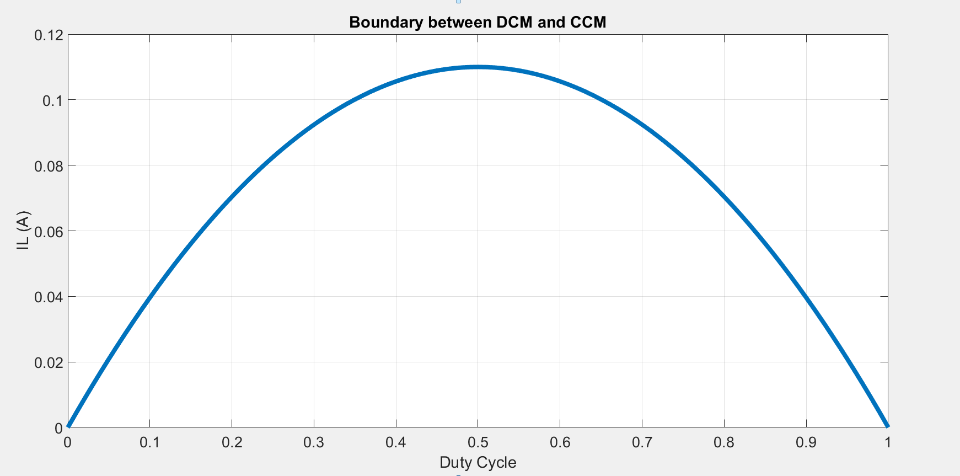

**Figure 1. Boundary between DCM and CCM**

As seen in the Figure the maximum current value for DCM is around 100mA, that value is enough for us because our load current is much higher.

**3. Simulation Results**

* In this part, to observe the effect of maximum current and voltage output, duty cycle is set to 100%.

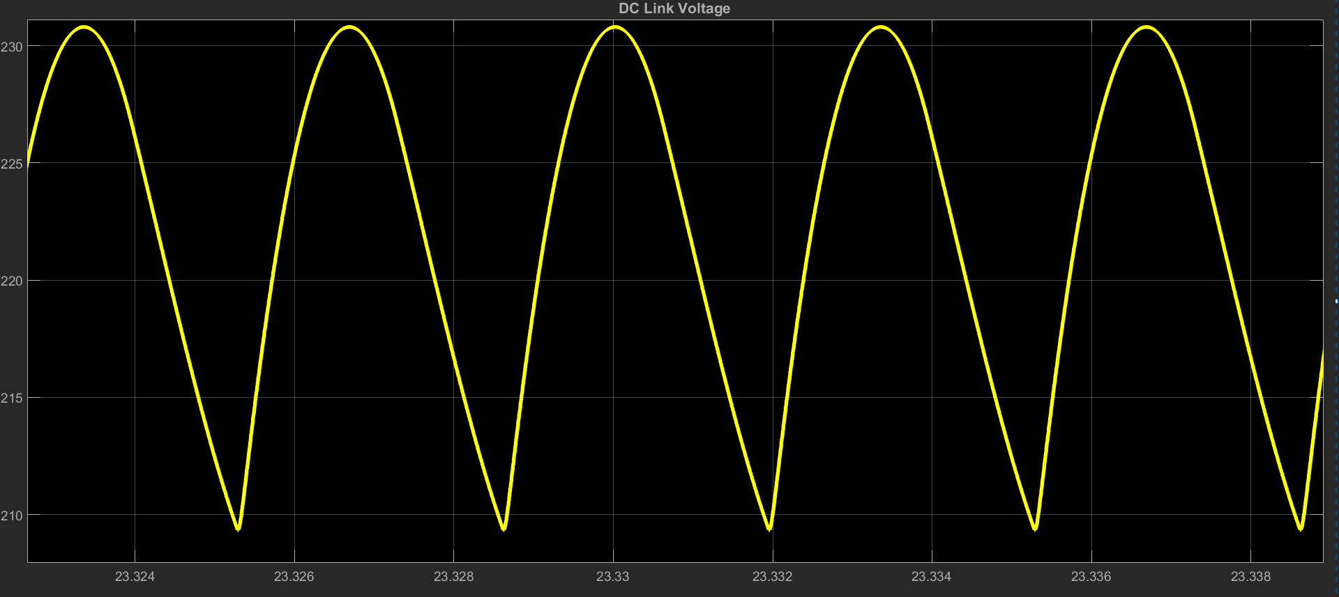

**Figure 2. DC Link Voltage**

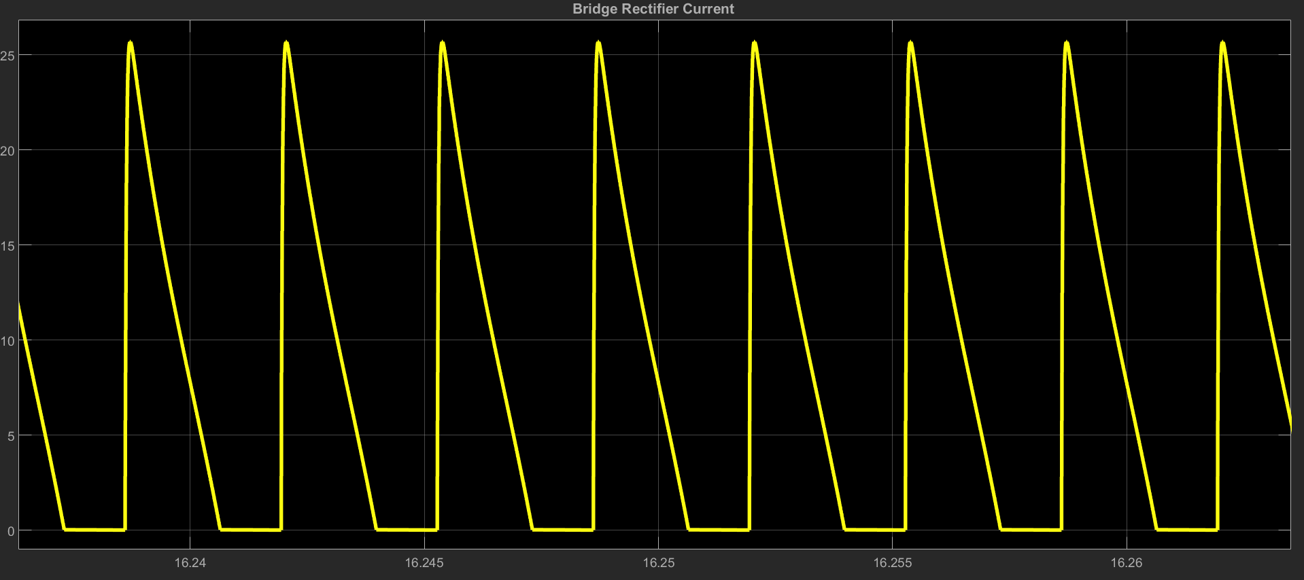

**Figure 3. Bridge Rectifier Current**

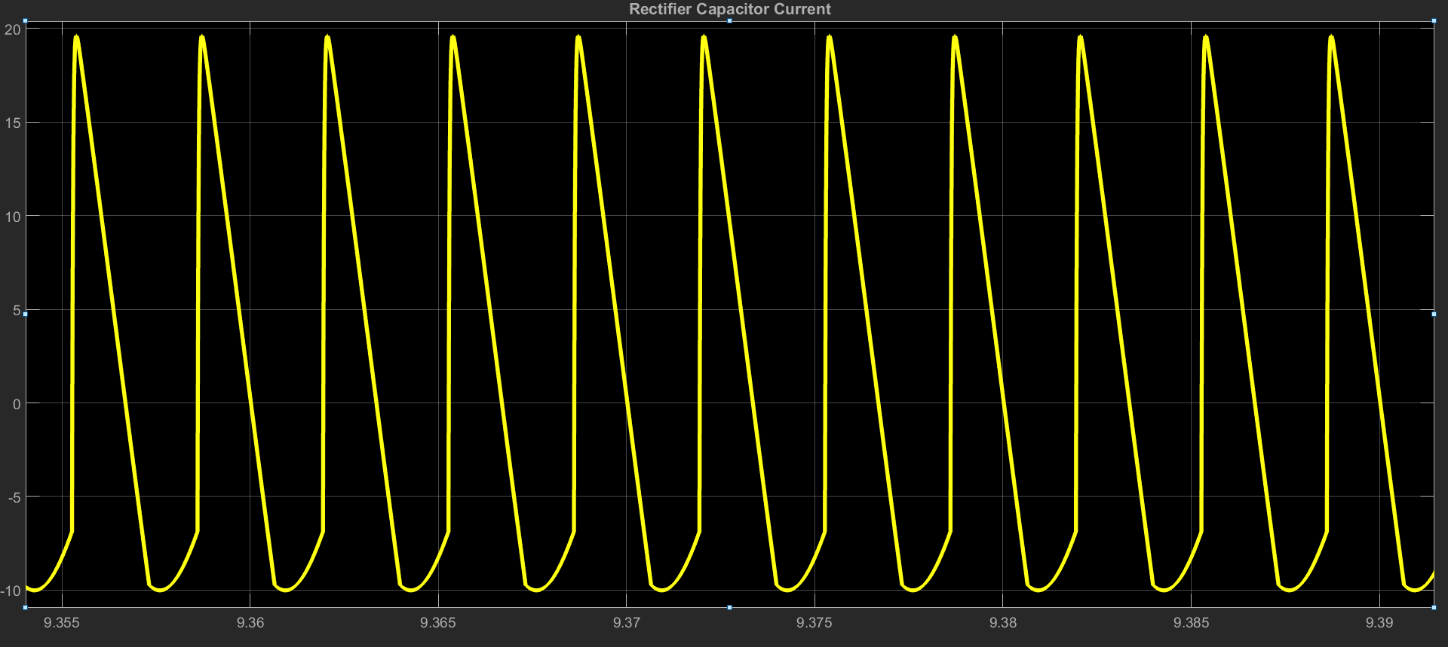

**Figure 4. Capacitor Current ( Rectifier side)**

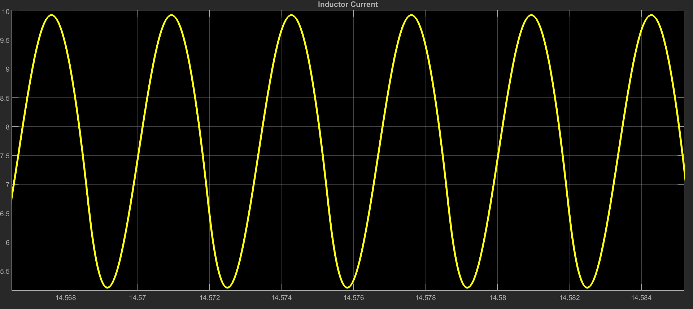

**Figure 5. Inductor Current**

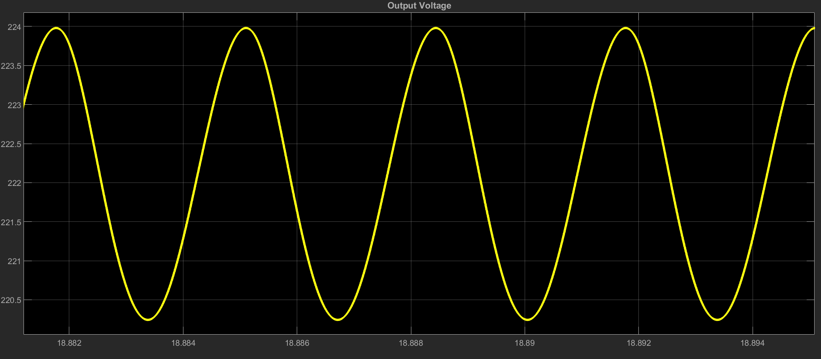

**Figure 6. Output Voltage**

* In this part, to observe the voltage across the freewheeling diode and IGBT, duty cycle is set to 50%. Moreover, the average current through the freewheeling diode reaches its max value around 50% - 60% duty cycle.

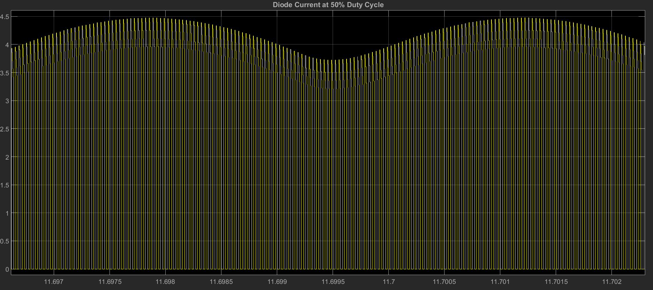

**Figure 7. Freewheeling Diode Current Waveform**

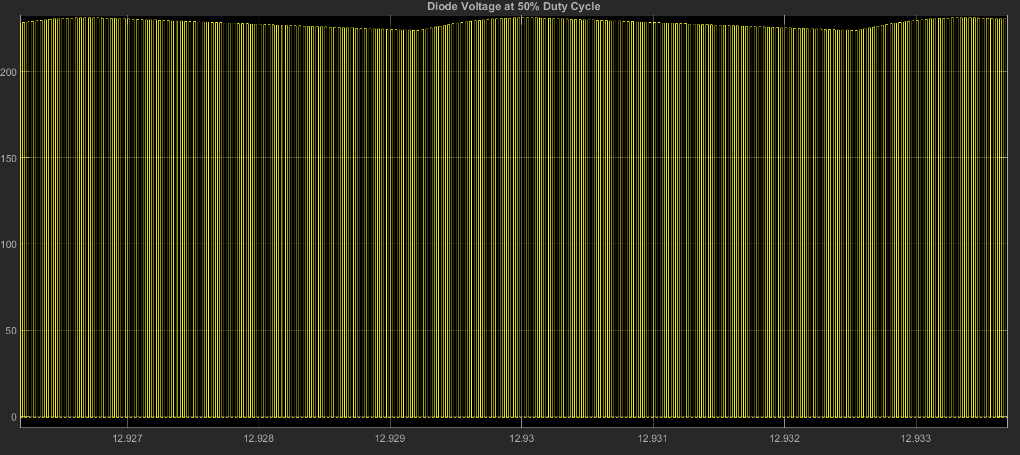

**Figure 8. Freewheeling Diode Voltage Waveform**

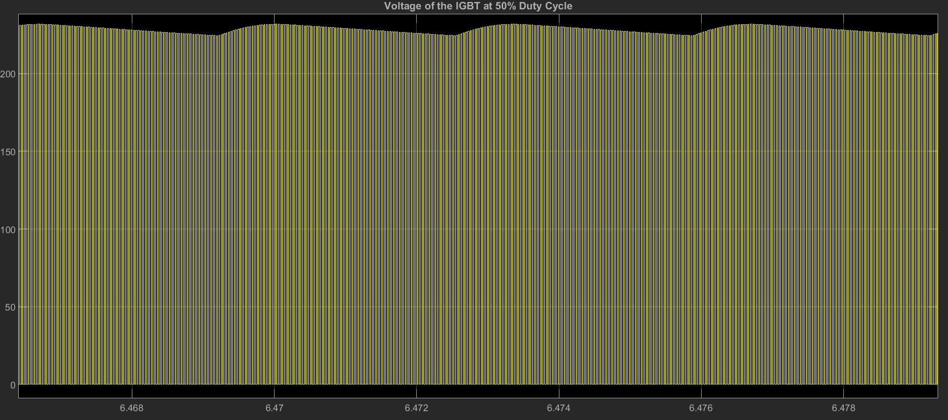

**Figure 9. VCE Voltage Waveform of the IGBT**

1. **Component selection**

The RMS of the line to neutral voltage of the 3-phase line is chosen as 95V which provides around 220V DC voltage at the output of the diode rectifier. At no load, the voltage and current values are observed for each components and ratings of the components is made accordingly.

The capacitors are chosen as aluminum electrolytic whose ratings are 450V 680µF. We couldn’t find the datasheet of the capacitors. They are named Kendeil K01450381.

The average voltage across the 3-phase diode bridge rectifier is 222V. However, while starting the voltage value reached up to 383.6V. The maximum average output current is 7.46A however the current swings between 0 and 28.65A. The reason for this swing is because we only used a capacitor for the filtering at the output of the rectifier. The component we chose is named SBR3516 which is capable of carrying 35A and can withstand up to 1600V.

The maximum voltage across the switching element is around 231.8V and average current flowing through it is around 7.48A and swings between 9.7A and 5A (at 100% duty cycle). Considering these, we have decided to use RJH60F7ADPK IGBT. VCE and IC ratings are 600V and 50A(100°C) respectively.

The maximum voltage across the freewheeling diode is 234V and average current flowing through is 2A at %50-60 duty cycle. We have used DSEI30-26A fast recovery diode. It has voltage and current rating of 1200V and 26A respectively. The reverse recovery time is 40 ns.

The average current through the inductor is around 7.66A at 99% duty cycle. To achieve continuous conduction mode the inductor value must be high enough. The components we found in the market were quite expensive for us. Therefore, we have bought a ferrite core and enameled wire. The diameter of the wire was around 2mm. datasheet of the core was not available; however, we have obtained 2.9mH inductance at 10 turns.

In order to drive the IGBT, isolation between the control signal and the power circuit is necessary. Moreover, the microcontroller cannot provide enough voltage to the gate of the IGBT. TLP250 optocoupler is used for this purpose. It provides isolation up to 2500V. The maximum switching time is 1.5µs which means it can do switching up to 666kHz.

1. **Thermal Considerations**

* Heat dissipation on the IGBT

VCEsat*IC + (Eon+Eoff)*fs = 1.35*7.46 + (100+ 250 µJ)*31250 = 21W

* Heat dissipation on the diode bridge

Around 15W at 7.5A of output current from the datasheet.

* Heat dissipation on the freewheeling diode

VON*ID = 1.65 * 2 = 3.3W

Most of the heat dissipation is on the IGBT. To provide cool operation we have attached a very large heatsink to the IGBT with an additional fan. The obtained test results are provided in the test results.

1. **Test Results**

**Results with the R Load:**

To test our design to drive the DC motor; firstly, R load with 80 ohms is connected to our design as a load. Then, we noted some results as following.

* Given diode rectifier output voltage as 220 Volts with the %95 duty cycle, 3 A load current is measured. Then, it is tested that if the output voltage can be controlled by changing the duty cycle. Given the 220 V diode rectifier output voltage with the %5 duty cycle, 13 V load voltage and 0 A load current are measured. So, it is checked that our buck converter design is capable to change the diode rectifier output voltage from 220 V to 13 V by changing the duty cycle from %95 to %5.
* When changing the duty cycle to its minimum value, maximum 50 degree is observed at the IGBT.

Secondly, R load with 50 ohms is connected as a load. Then, we noted some

results as following.

* Given diode rectifier output voltage as 220 Volts with the %95 duty cycle, 5 A load current is measured. Then, it is checked that our buck converter design is capable to change the diode rectifier output voltage from 220 V to lower voltages by changing the duty cycle from %95 to %30. But when changing the duty cycle lower than %30, the mosfet has started to warm up speed and we had to stop changing it.
* When changing the duty cycle to its minimum value, more than 80 degrees is observed on the IGBT.

**Results with the DC Motor Running:**

After the R load test; firstly, DC motor from standstill to rated speed under no load is tested and we observed some results as following.

**Table 2. Motor characteristics at different duty cycles under no load**

|  |  |  |  |
| --- | --- | --- | --- |
| **Duty Cycle** | **Armature Voltage (V)** | **Armature Current (A)** | **Motor Speed**  **(rpm)** |
| %95 | 231 | 2 | 1272 |
| %70 | 181 | 2 | 1167 |
| %30 | 138 | 2 | 992 |

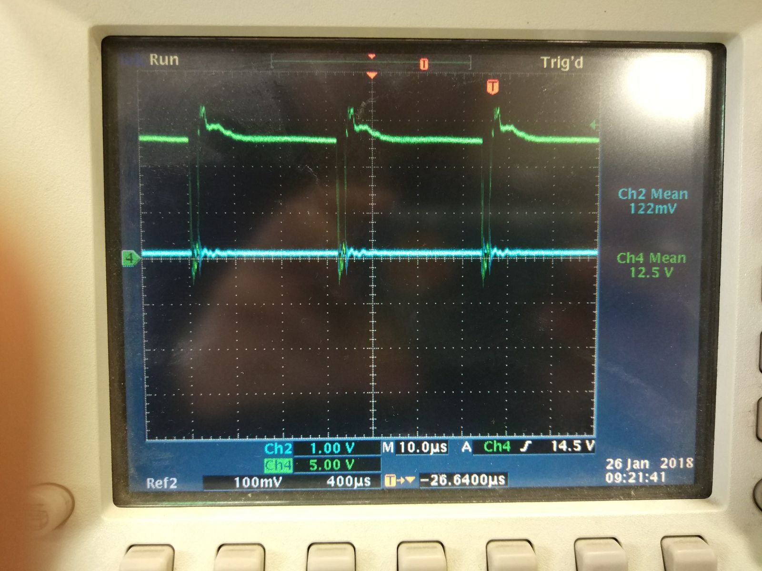

**Figure 10. VGE voltage at 95% duty cycle**

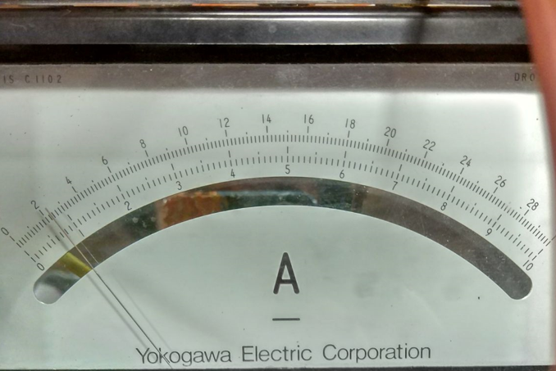

**Figure 11. Armature current 95% duty cycle**

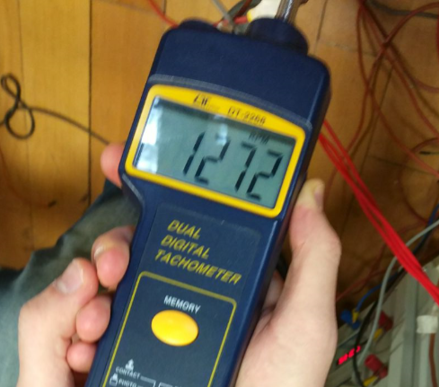

**Figure 12. Rotor speed at 95% duty cycle**

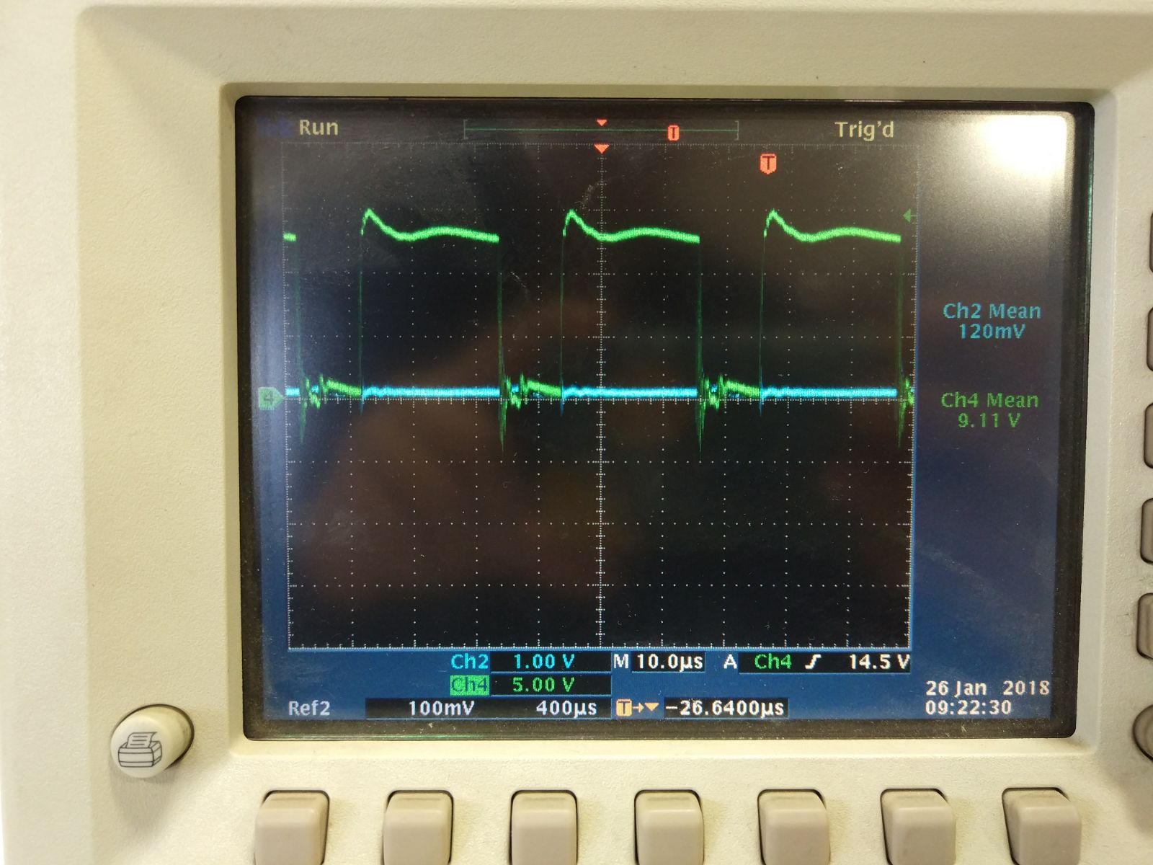

**Figure 13. VGE voltage at 70% duty cycle**

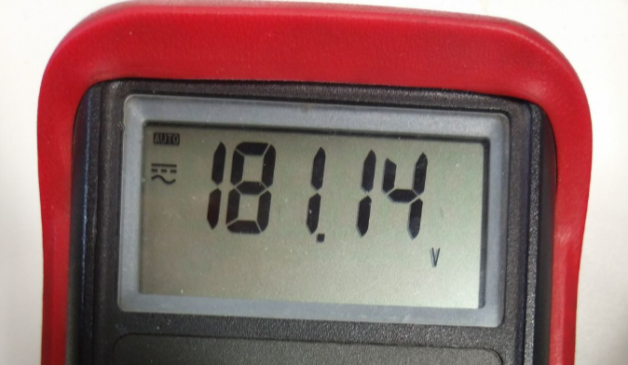

**Figure 14. Armature voltage at 70% duty cycle**

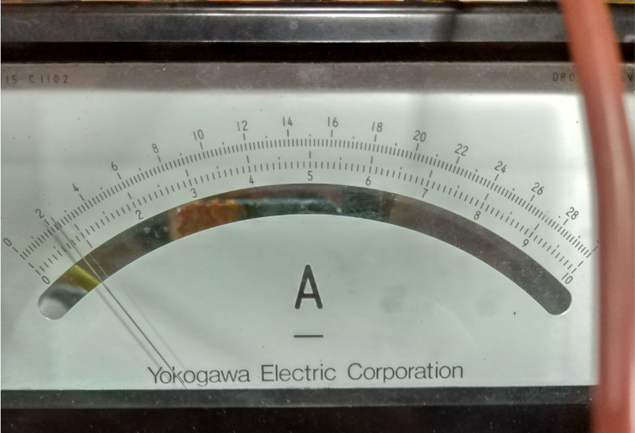

**Figure 15. Armature at 70% duty cycle (30A scale)**

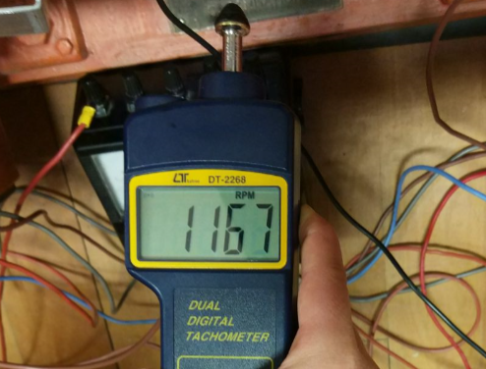

**Figure 16. Rotor speed at 70% duty cycle**

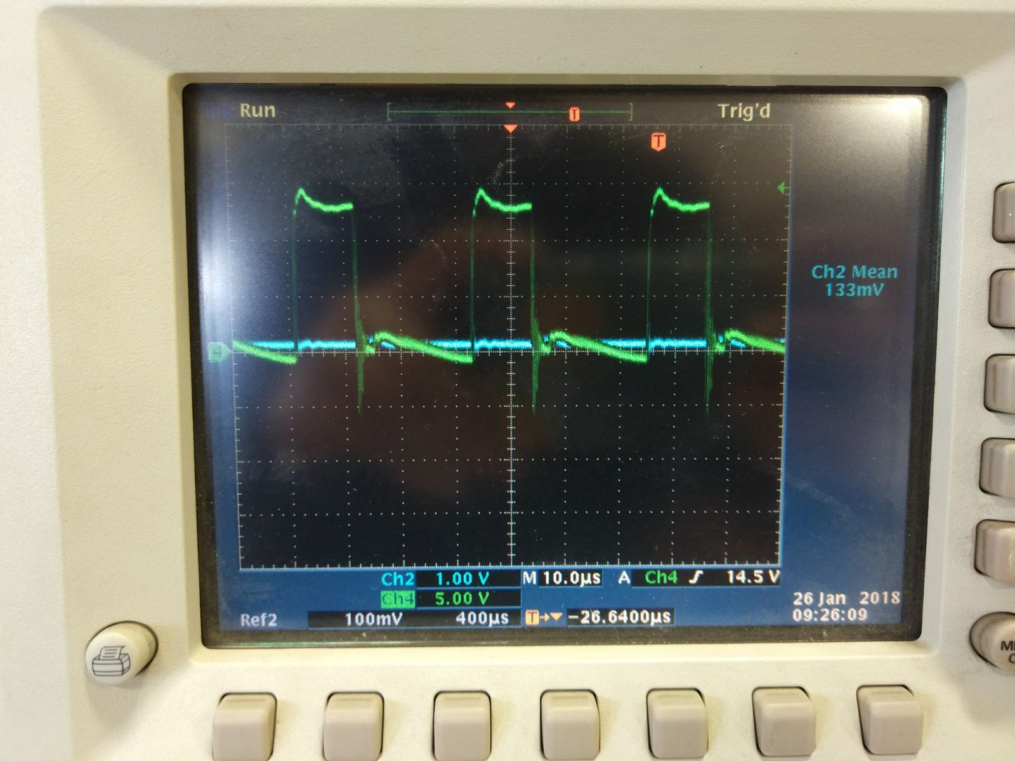

**Figure 17. VGE voltage at 30% duty cycle**

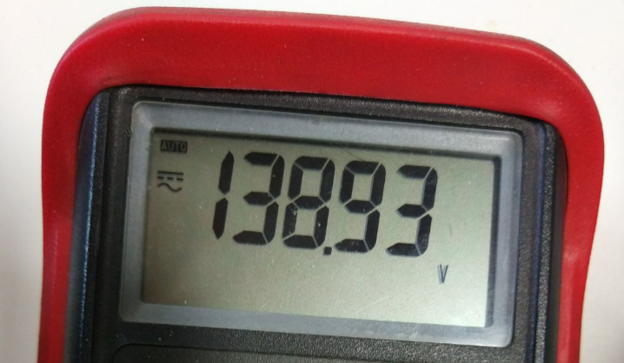

**Figure 18. Armature voltage at 30% duty cycle**

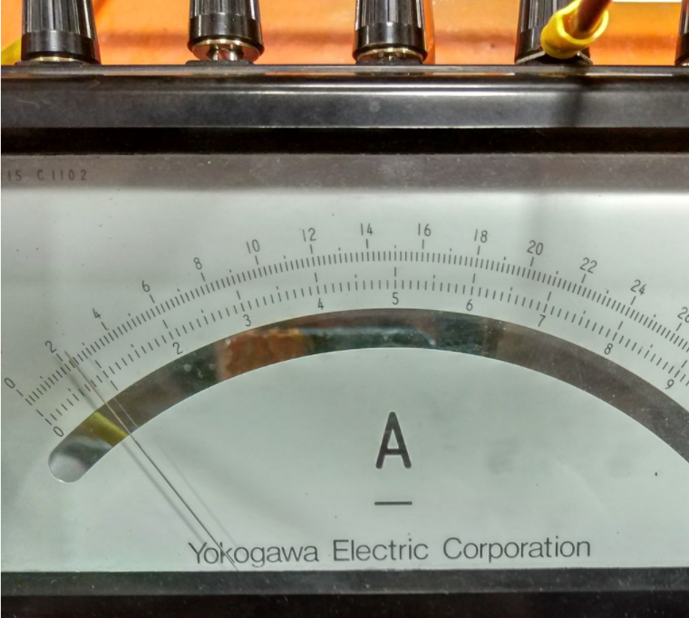

**Figure 19. Armature current at 30% duty cycle**

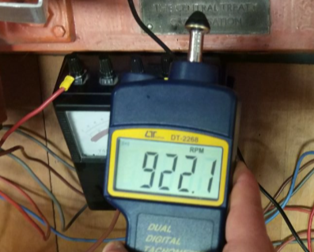

**Figure 20. Rotor speed at 30% duty cycle**

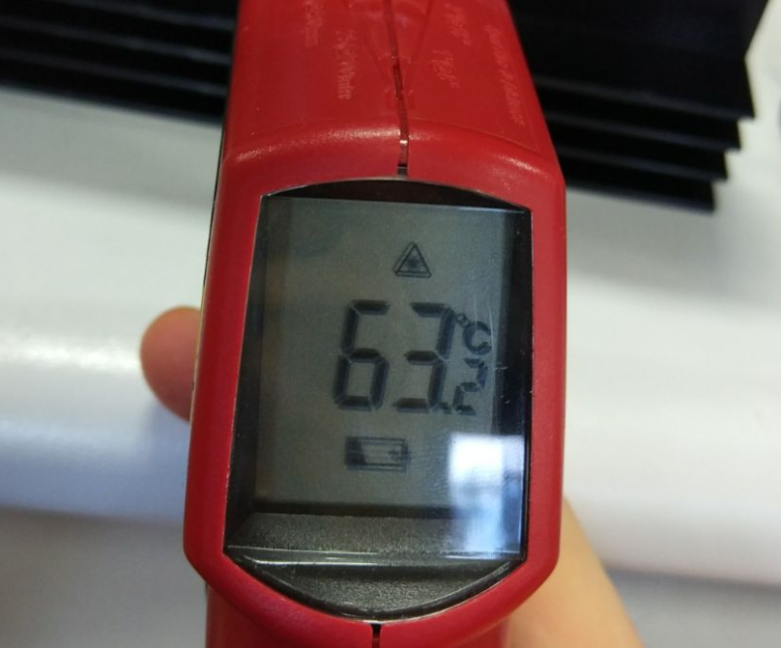

**Figure 21. IGBT temperature at 30% duty cycle**

Secondly, a test of 10 min under full-load with rated speed and %95 duty cycle is done and some results are obtained as following.

**Table 3. Motor characteristics at under full load**

|  |  |  |
| --- | --- | --- |
| Armature voltage (V) | Armature current (A) | Field Voltage (V) |
| 190 | (more than) 10 | 220 |

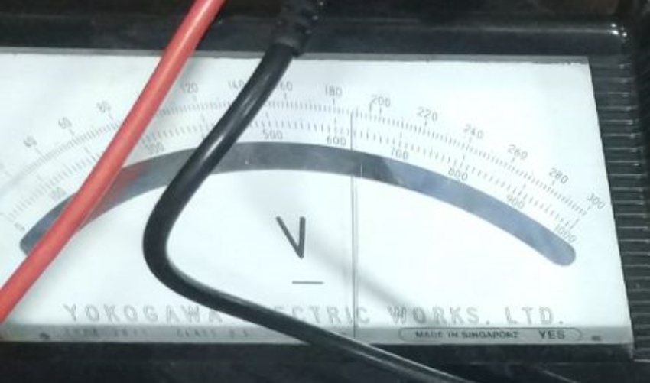

**Figure 22. Armature voltage at Full load**

**

**Figure 23. Armature current at Full load**

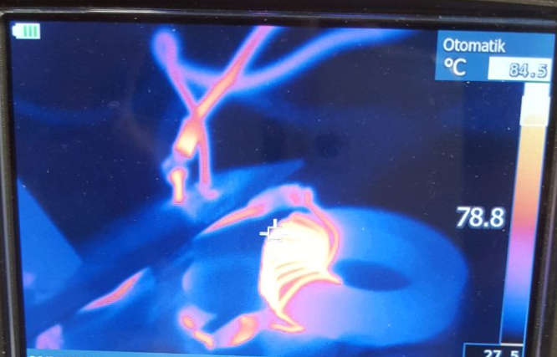

**Figure 24. Temperature of the inductor under full load test**

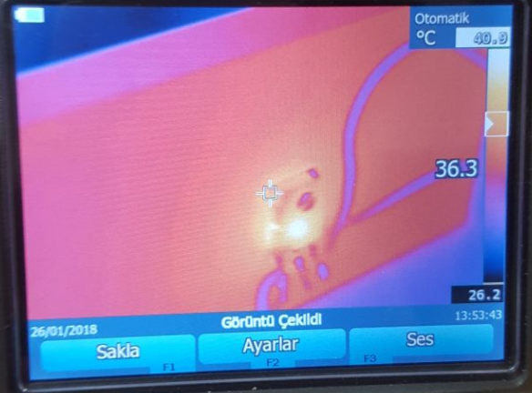

**Figure 25. Temperature of IGBT at the starting of Full Load Test**

The temperature of the IGBT and the diode bridge rectifier went up to 85 °C and 95°C at the end of the full load test

**7. Conclusions**

Designing and implementing of a power circuit is a challenging process. During this project we have been familiar with the problems in the application side. These can be summarized as choosing passive elements and heatsinks, control of the switching elements, implementation of the circuit.

During the testing of the circuit we have burned a few switching elements. We think this is because of the ringing while driving the IGBT. These oscillations are caused due to the long cables that we have used while the implementation and high switching frequency. Other than switching elements, we observed that passive elements may need cooling as well. The heat of the inductor went up to 85 °C degrees under full load test.